GOIP SMS Management Server Manual 1.0
Introduction：
GOIP SMS Management Server is used to control sending message. User can send、search or other operations on the web server
Installation Requirements：
Be sure that apache2(or above version)、php4(or above version) and mysql4.1(or above version) has been installed on the Linux system. The software is used UTF-8 character coding.

Installation
一、Windows system installation
1)install php、mysql and apache
2)download http://dbltek.com/update/goip_install.tgz, decompression the software: goip_install.tgz，copy “goip” directory to the directory of apache server (maybe the default directory is htdocs/ or www/)
3)click “import_sql.cmd”in goip\inc，you will see the screen. Then input password of root.(the mysql process should be started up. If “mysql command is not recognized” appeared , you should input database by yourself: click “start-> run”, input “cmd” and then input command: mysql installation path/mysql/bin/mysql -uroot -p < apache server directory/goip/inc/goipinit.sql)
4)double click “install.cmd” to install
5)The default enabled UDP port is 44444.If a firewall installed, please join the trust 44444 UDP port list.
6)Input GOIP manager URL: http://your_ip/goip in your brower, user: root password:root
7) Set providers in "System Manage -> Provider Manage"
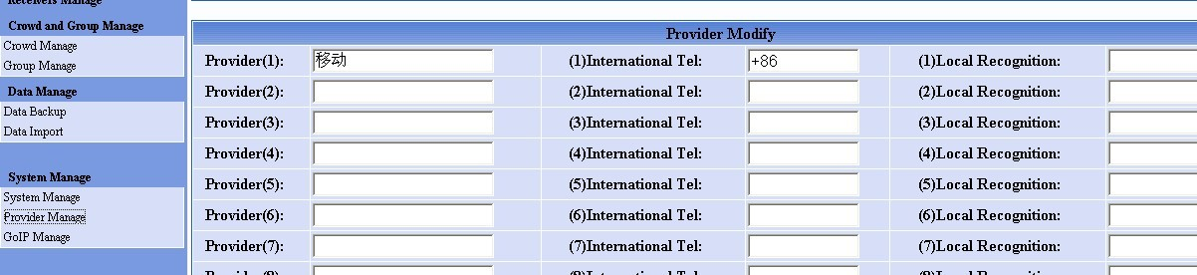
8) Click “GoIP Manage”, add ID and password to goip parameter management.
9) Open GOIP configuration webpage，fill the parameters in corresponding blank，the default port is 44444. then then goip will login in sms server.
10）Now you can send message. Or you can create groups and contact to send sms.

二、Linux system installation

1) Login Linux system as root
input command
wget http://dbltek.com/update/goip_install.tgz
input command
tar –xzvf goip_install.tgz
input command
cd goip_install
input command
./goip_install.sh

2) installation processing as this:
./goip_install.sh (Starting GoIP SMS System install)

Configure httpd config:
Enter the httpd config file PATH:
The default httpd configuration file path is “/etc/httpd/conf/httpd.conf ”, default press Enter

Choose your Mysql Database version:
4
5
The default mysql version is 4

Import GOIP databased
Input the Mysql root password if the password exists:

Enter your Mysql PATH
The default Mysql path is“/usr/bin/mysql”，default press Enter

Copying file to /usr/local/goip

Install finished

3) The default enabled UDP port is 44444.If a firewall installed, please join the trust 44444 UDP port list.
4) Then restart your httpd.
5) Input GOIP manager URL: http://your_ip/goip in your broswer, user: root password:root
6) set providers in "System Manage -> Provider Manage"
7) Click “GoIP Manage”, add ID and password to goip parameter management.
8) Open GOIP configuration webpage，fill the parameters in corresponding blank，the default port is 44444. then then goip will login in sms server.
9）Now you can send message. Or you can create groups and contact to send sms.

